Lab report sheet
(Functional Group lab)
Total points: 524
Important notes:
- Please make sure you use “STRUCTURAL FORMULAS” when filling out the box for “chemical reactions” in each segment of this lab. Molecular formulas will NOT be accepted and will not be graded. You can omit combustion reaction in the chemical equations. You can either hand-draw structures or use freely available “ChemSketch” or Biovia software. These can be downloaded free from their websites. Formulas copied from the Internet will not be acceptable and will merit zero credit!
- Each observation and inference box in the tests sections has 4 points.
- Each chemical equation (with structural formulas) carries 4 points. Make sure your equations are complete.

NOTE: All the observations/questions in this lab report refer to the Flow chart (uploaded in the “Files” folder). Please follow this while completing this lab. To know the test and their chemical reaction equations, you must consult first the ppt (unnarrated and narrated) uploaded in Canvas, and then the manual in case you need more information.
(For a quick reference to all chemical tests, you can use the Canvas file “Summary of chemical tests”).
- Observations about the test of known compounds (hypothetical – assuming you actually did the experiment in the lab):
- You analyzed 2-pentene in the lab by following the Flow chart uploaded in Canvas. Record your observations as follows (your observations must be in accordance with what you expect of this compound).
Compound analyzed | Experiment | Observation | Inference  (what FG could be absent or present)
2-pentene | Performed ignition/combustion test | Yellow flame observed but no soot | Aromatic ring or alkynes absent
 | Performed Beilstein test | No green/blue color observed in flame | Halogens absent
 | Placed two drops of the compound in a test tube. Added about 1 mL of water. Stirred with a glass rod to solubilize the compound. Then warned it in a 60-70 °C water bath. | Immiscible, floats on cold as well as warm water | Absence of low molecular weight alcohols, amines, carboxylic acids
 | Added ~ 1 mL of 5% NaOH solution to andstirredwith a glass rod. | Immiscible | Compound is neither weak nor strongly acidic. So, phenol and carboxylic acid groups are absent.
 | Added a few drops of 5% NaHCO₃ to the compound and watched to see if tiny bubbles of carbon dioxide were produced | No bubbles observed | Carboxylic acid (-COOH) group is absent
 | Added a few drops of 5% HCl to the compound and watched to see if the compound dissolved. | Immiscible | Amines absent
 | Dissolved 3 drops of the compound in 2 mL of reagent-grade ethanol and added 3 mL of the 2,4-dinitrophenylhydrazine (2,4-DNP) reagent | Precipitates are not observed | Aldehydes/Ketones absent
 | Added 3 drops of the compound to a test tube then added 5 drops of acetone and 5 drops of chromic acid solution. | No color change | Alcohols and aldehydes absent
 | Dissolve about 2 drops of the compound in about 0.5 ml of  Dichloromethane (DCM) in a small test tube. Add 4 drops of 2% bromine in dichloromethane solution. | Reddish brown color of bromine disappears | Unsaturated compounds i.e. Alkenes or alkynes are present
 | Dissolve 1 drop of the compound in 0.5 mL acetone. Add a 1% aqueous solution of potassium permanganate. | Purple color of KMnO4 disappears | Unsaturated compounds i.e. Alkenes or alkynes are present
Chemical equation/s of the reaction/s that gave definitive (confirmatory) information about this compound. You must use STRUCTURAL FORMULAS (hand-drawn, soft-ware drawn (NOT copied from the internet! Molcular formulas will not be acceptable and will get no credit.
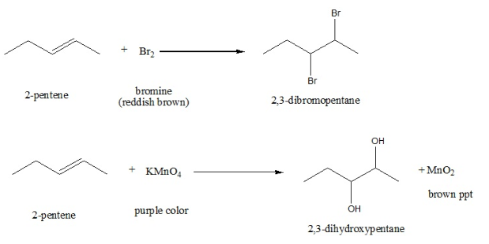

- Observations about the known compounds (hypothetical – considering you actually did the experiment in the lab):
- You analyzed 1-butanol in the lab by following the Flow chart uploaded in Canvas. Record your observations as follows (your observations must be in accordance with what you expect of this compound).
Compound analyzed | Experiment | Observation | Inference  (what FG could be absent or present)
1-butanol | Performed ignition/combustion test | Flame is not sooty | Aliphatic compound present
 | Performed Beilstein test | Flame is not green | Absence of halides
 | Placed two drops of the compound in a test tube. Added about 1 mL of water. Stirred with a glass rod to solubilize the compound. Then warned it in a 60-70 °C water bath. | Water soluble | Polar compound present
 | Added ~ 1 mL of 5% NaOH solution to and stirred with a glass rod. | Soluble in sodium hydroxide | Absence of basic groups
 | Performed litmus test | Negative | Absence of acidic groups
 | Added a few drops of 5% NaHCO₃ to the compound and watched to see if tiny bubbles of carbon dioxide were produced | There is no carbon (iv) oxide produced | Absence of carboxylic acid group
 | Added a few drops of 5% HCl to the compound and watched to see if the compound dissolved. | Compound is not soluble | Basic groups e.g. amines are absent
 | Dissolved 3 drops of the compound in 2 mL of reagent-grade ethanol and added 3 mL of the 2,4-dinitrophenylhydrazine (2,4-DNP) reagent | There is no orange precipitate seen | Aldehyde and ketone are absent
 | Added 3 drops of the compound to a test tube then added 5 drops of acetone and 5 drops of chromic acid solution. | A green color is seen | Presence of a primary or a secondary alcohol
 | Added 0.1 mL of the compound to a test tube and then added 1 mL of the hydrochloric acid/zinc chloride (Lucas reagent) reagent. Thoroughly stirred the mixture with a stirring rod and let the tube stand for 5-10 min. | There is no turbidity noticed | Absence of secondary alcohol
 | Heated the above mixture in boiling water for several min | There is some turbidity noticed | Presence of a primary alcohol.
Chemical equation/s of the reaction/s that gave definitive (confirmatory) information about this compound. You must use STRUCTURAL FORMULAS (hand-drawn, soft-ware drawn (NOT copied from the internet! Molcular formulas will not be acceptable and will get no credit.

3RCH₂OH + 2CrO₃ + 3H₂SO₄ 3RCOOH + H₂O + Cr₂(SO4)₃
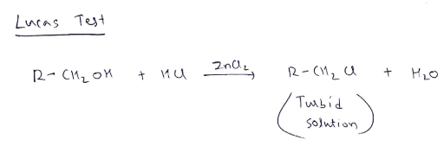

- Observations about the known s (hypothetical – considering you actually did the experiment in the lab):
- You analyzed 2-butanol in the lab by following the Flow chart uploaded in Canvas. Record your observations as follows (your observations must be in accordance with what you expect of this compound).
analyzed | Experiment | Observation | Inference  (what FG could be absent or present)
2-butanol | Performed ignition/combustion test | Flame is not sooty | Aliphatic compound present
 | Performed Beilstein test | Flame is not green | Absence of halides
 | Placed two drops of the compound in a test tube. Added about 1 mL of water. Stirred with a glass rod to solubilize the compound. Then warned it in a 60-70 °C water bath. | Water soluble | Polar compound present
 | Performed litmus test | Soluble in sodium hydroxide | Absence of basic groups
 | Added ~ 1 mL of 5% NaOH solution to and stirred with a glass rod. | Negative | Absence of acidic groups
 | Added a few drops of 5% NaHCO₃ to the compound and watched to see if tiny bubbles of carbon dioxide were produced | There is no carbon (iv) oxide produced | Absence of carboxylic acid group
 | Added a few drops of 5% HCl to the compound and watched to see if the compound dissolved. | Compound is not soluble | Basic groups e.g. amines are absent
 | Dissolved 3 drops of the compound in 2 mL of reagent-grade ethanol and added 3 mL of the 2,4-dinitrophenylhydrazine (2,4-DNP) reagent | There is no orange precipitate seen | Aldehyde and ketone are absent
 | Added 3 drops of the compound to a test tube then added 5 drops of acetone and 5 drops of chromic acid solution. | A green color is seen | Presence of a primary or a secondary alcohol
 | Added 0.1 mL of the compound to a test tube and then added 1 mL of the hydrochloric acid/zinc chloride reagent (Lucas reagent). Thoroughly stirred the mixture with a stirring rod and let the tube stand for 5-10 min. | There is no turbidity noticed | Absence of secondary alcohol
 | Heated the above mixture in boiling water for several min | There is some turbidity noticed | Presence of a primary alcohol.
Chemical equation/s of the reaction/s that gave definitive (confirmatory) information about this compound. You must use STRUCTURAL FORMULAS (hand-drawn, soft-ware drawn (NOT copied from the internet! Molcular formulas will not be acceptable and will get no credit.

- Observations about the known s (hypothetical – considering you actually did the experiment in the lab):
- You analyzed 2-methyl-2-propanol (tertiary butyl alcohol) in the lab by following the Flow chart uploaded in Canvas. Record your observations as follows (your observations must be in accordance with what you expect of this compound).
analyzed | Experiment | Observation | Inference  (what FG could be absent or present)
2-methyl-2-propanol (tert. butyl alcohol) | Performed ignition/combustion test | burns with blue flame with no smoke | alcohol may be present
 | Performed Beilstein test | no blue green color flame is observed | halides are absent
 | Placed two drops of the compound in a test tube. Added about 1 mL of water. Stirred with a glass rod to solubilize the compound. Then warned it in a 60-70 °C water bath. | Miscible in water but not with NaOH | Alcohol may be present and carboxylic acid groups are absent.
 | Added ~ 1 mL of 5% NaOH solution to and stirred with a glass rod.
 | Performed litmus test | no change in litmus paper color | Carboxylic acid groups are absent  Alcohol may be present as they are neutral in nature
 | Added a few drops of 5% NaHCO₃ to the compound and watched to see if tiny bubbles of carbon dioxide were produced | There is no reaction observed | Carboxylic acid groups are absent
 | Added a few drops of 5% HCl to the compound and watched to see if the compound dissolved. | No reaction is observed | amines are absent
 | Dissolved 3 drops of the compound in 2 mL of reagent-grade ethanol and added 3 mL of the 2,4-dinitrophenylhydrazine (2,4-DNP) reagent | No reaction is observed | aldehydes and ketones are absent
 | Added 3 drops of the compound to a test tube then added 5 drops of acetone and 5 drops of chromic acid solution. | no color change or reaction is observed | Primary and secondary alcohols are absent, tertiary alcohol may be present.
 | Added 0.1 mL of the compound to a test tube and then added 1 mL of the hydrochloric acid/zinc chloride reagent (Lucas reagent). Thoroughly stirred the mixture with a stirring rod and let the tube stand. | turbidity is observed in the solution | presence of tertiary alcohol
Chemical equation/s of the reaction/s that gave definitive (confirmatory) information about this compound. You must use STRUCTURAL FORMULAS (hand-drawn, soft-ware drawn (NOT copied from the internet! Molcular formulas will not be acceptable and will get no credit.
(ZnCl2)
ROH + HCl -----------> RCl + H2O

analyzed | Experiment | Observation | Inference  (what FG could be absent or present)
Phenol | Performed ignition/combustion test | Orange or deep-yellow flame which is sooty is seen. | Presence of an aromatic compound
 | Performed Beilstein test | No blue or green color is seen | Absence of Halides
 | Placed two drops of the compound in a test tube. Added about 1 mL of water. Stirred with a glass rod to solubilize the compound. Then warned it in a 60-70 °C water bath. | Slightl solubility in water
 | Performed litmus test on the hot solution above | Blue litmus paper turns red | Presence of an acidic part
 | Added ~ 1 mL of 5% NaOH solution to and stirred with a glass rod. | The solution mixes and the solution becomes transparent | Presence of an acidic part or group
 | Added a few drops of 5% NaHCO₃ to the compound and watched to see if tiny bubbles of carbon dioxide were produced | There is no effervescence formed. | COOH or SO3H groups absent.
 | Suspended or dissolved 30 mg or 1 drop of the phenol in 1 mL of chloroform. Add 1 drop of pyridine and 3 drops of a 0.06 M solution of anhydrous ferric chloride in chloroform. unknow | Deep blue color is formed | Phenolic OH group is not present.
Chemical equation/s of the reaction/s that gave definitive (confirmatory) information about this compound. You must use STRUCTURAL FORMULAS (hand-drawn, soft-ware drawn (NOT copied from the internet! Molcular formulas will not be acceptable and will get no credit.

- Observations about the known s (hypothetical – considering you actually did the experiment in the lab):
- You analyzed 1-butanamine in the lab by following the Flow chart uploaded in Canvas. Record your observations as follows (your observations must be in accordance with what you expect of this compound).
analyzed | Experiment | Observation | Inference  (what FG could be absent or present)
1-butanamine | Performed ignition/combustion test | Gases are produced on burning | 1-Butanamine on ignition gives carbon dioxide, water vapour and toxic oxides of nitrogen. Turning of lime water milky can be seen to confirm production of carbon dioxide gas.
 | Performed Beilstein test | No green color is seen suggesting negative Beilstein test | No halogen present
 | Placed two drops of in a test tube. Added about 1 mL of water. Stirred with a glass rod to solubilize the compound. | Compound is miscible in water | The compound is soluble
 | Performed litmus test on the hot solution above | Aqueous solutions of the compound turned red litmus paper into blue color | It is alkaline in nature.
 | Dissolved a few drops of the compound in 2 mL water containing 8 drops of concentrated H₂SO₄. Cooled the test tube in ice/water mixture.  In a second test tube, added 2 mL of 10% sodium nitrite solution and cooled it in ice/water mixture.  Added the cold solution of sodium nitrite dropwise with shaking to the test tube containing the compound in H₂SO₄ and watched for evolution of nitrogen gas | Diazotization reaction takes place. | This is a primary amine; diazotization reaction takes place and a diazo salt is formed; and later Nitrogen is involved.
Chemical equation/s of the reaction/s that gave definitive (positive) information about this.

- Observations about the known s (hypothetical – considering you actually did the experiment in the lab):
- You analyzed aniline in the lab by following the Flow chart uploaded in Canvas. Record your observations as follows (your observations must be in accordance with what you expect of this compound).
analyzed | Experiment | Observation | Inference  (what FG could be absent or present)
aniline | Performed ignition/combustion test | Sooty flame was observed | Aromatic compound present
 | Performed Beilstein test | Green flame was not observed | Alkyl halide is absent
 | Placed two drops of the compound in a test tube. Added about 1 mL of water. Stirred with a glass rod to solubilize the compound. Then warned it in a 60-70 °C water bath. | No clear solution is observed | Water insoluble compound
 | Performed litmus test | Turns red litmus to blue | Presence of a Basic compound
 | Added ~ 1 mL of 5% NaOH solution to and stirred with a glass rod. | Insoluble | Alcohols, phenols are absent
 | Added a few drops of 5% NaHCO₃ to the compound and watched to see if tiny bubbles of carbon dioxide were produced | No bubbles of CO2 were observed | Carboxylic acid is absent
 | Added a few drops of 5% HCl to the compound and watched to see if the compound dissolved (aniline is a very weak base, unlike aliphatic amines). | Soluble | Amine is present
 | Dissolved 3 drops of the compound in 2 mL of reagent-grade ethanol and added 3 mL of the 2,4-dinitrophenylhydrazine (2,4-DNP) reagent | There is no yellow precipitate observed | Carbonyl group (Aldehyde/ketone) is absent
 | Added 0.1 mL of the compound to a test tube and then added 1 mL of the hydrochloric acid/zinc chloride reagent (Lucas reagent). Thoroughly stirred the mixture with a stirring rod and let the tube stand for 5-10 min. | No cloudy solution was observed | Alcohols are absent
 | Heated the above mixture in boiling water for several min | No reaction | Alcohols are absent
 | Dissolved a few drops of the compound in 2 mL water containing 8 drops of concentrated H₂SO₄. Cooled the test tube in ice/water mixture.  In a second test tube, added 2 mL of 10% sodium nitrite solution and cooled it in ice/water mixture.  In a third test tube, dissolved 0.1 g of -naphthol in 2 mL of 10% NaOH solution and placed it in the ice/water bath.  Added the cold solution of sodium nitrite dropwise with shaking to the test tube containing the unknown in H₂SO_{4.}  Added the basic cold solution of -naphthol solution from the 3rd test tube. | Purple ring was not observed | Carbohydrates are absent
Chemical equation/s of the reaction/s that gave definitive (confirmatory) information about this compound. You must use STRUCTURAL FORMULAS (hand-drawn, soft-ware drawn (NOT copied from the internet! Molcular formulas will not be acceptable and will get no credit.

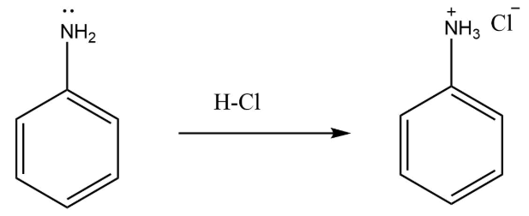

- Observations about the known s (hypothetical – considering you actually did the experiment in the lab):
- You analyzed N-methyl aniline (a secondary amine) in the lab by following the Flow chart uploaded in Canvas. Record your observations as follows (your observations must be in accordance with what you expect of this compound).
analyzed | Experiment | Observation | Inference  (what FG could be absent or present)
N-methyl aniline (a secondary amine) | Performed ignition/combustion test | Burns with a sooty flame | This is a confirmation of the presence of an aromatic compound
 | Performed Beilstein test | There is no distinct green color flame is seen | This confirms the presence of a halogen (Br, Cl, I). It is good to note that Fluorine does not give Beilstein test).
 | Placed two drops of the compound in a test tube. Added about 1 mL of water. Stirred with a glass rod to solubilize the compound. Then warned it in a 60-70 °C water bath. | Insoluble | The compound has non-polar characteristics
 | Performed litmus test | Turns blue | Basic compound confirmed
 | Added ~ 1 mL of 5% NaOH solution to and stirred with a glass rod. | Insoluble | The compound is not acidic, it has more basic characteristics
 | Added a few drops of 5% NaHCO₃ to the compound and watched to see if tiny bubbles of carbon dioxide were produced | Insoluble | The compound dos not contain a –COOH group.  Carboxylic acids react with NaHCO₃ to produce CO₂ gas with effervescence.
 | Added a few drops of 5% HCl to the compound and watched to see if the compound dissolved (aniline is a very weak base, unlike aliphatic amines). | Soluble | This confirms that the compound is basic
 | Dissolved 3 drops of the compound in 2 mL of reagent-grade ethanol and added 3 mL of the 2,4-dinitrophenylhydrazine (2,4-DNP) reagent | No yellow or orange precipitate that forms | This confirms the absence of Aldehyde and ketone functional groups
 | Added 0.1 mL of the compound to a test tube and then added 1 mL of the hydrochloric acid/zinc chloride reagent (Lucas reagent). Thoroughly stirred the mixture with a stirring rod and let the tube stand for 5-10 min. | There is no turbidity observed | Confirms the absence of Alcohol (-OH) functional group.
 | Heated the above mixture in boiling water for several min | No open flames | Decomposition happens
 | Dissolved a few drops of the compound in 2 mL water containing 8 drops of concentrated H₂SO₄. Cooled the test tube in ice/water mixture.  In a second test tube, added 2 mL of 10% sodium nitrite solution and cooled it in ice/water mixture.  Added the cold solution of sodium nitrite dropwise with shaking to the test tube containing the unknown in H₂SO_{4.} | There is a seen yellow oil layer that forms | This confirms the presence of a secondary amine
Chemical equation/s of the reaction/s that gave definitive (confirmatory) information about this compound. You must use STRUCTURAL FORMULAS (hand-drawn, soft-ware drawn (NOT copied from the internet! Molcular formulas will not be acceptable and will get no credit.

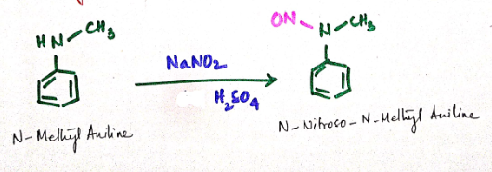

- Observations about the known compounds (hypothetical – considering you actually did the experiment in the lab):
- You analyzed benzaldehyde in the lab by following the Flow chart uploaded in Canvas. Record your observations as follows (your observations must be in accordance with what you expect of this compound).
Compound analyzed | Experiment | Observation | Inference  (what FG could be absent or present)
Benzaldehyde | Performed ignition/combustion test | Clear/colorless to pale yellow with almond is seen | Combustion flash
 | Performed Beilstein test | Halogen confirmation test | Beilstein test is positive
 | Placed two drops of the compound in a test tube. Added about 1 mL of water. Stirred with a glass rod to solubilize the compound. Then warned it in a 60-70 °C water bath. | Insoluble | More denser than water – it sinks
 | Added ~ 1 mL of 5% NaOH solution to and stirred with a glass rod. | Soluble | It forms benzoic acid on benzyl alcohol
 | Added a few drops of 5% NaHCO₃ to the compound and watched to see if tiny bubbles of carbon dioxide were produced | Insoluble | There are no carbon bubbles formed
 | Added a few drops of 5% HCl to the compound and watched to see if the compound dissolved. | Insoluble | Confirms that it is not basic
 | Dissolved 3 drops of the compound in 2 mL of reagent-grade ethanol and added 3 mL of the 2,4-dinitrophenylhydrazine (2,4-DNP) reagent | An orange precipitate was formed | This confirms he presence of a carbonyl group
 | Added 3 drops of the compound to a test tube then added 5 drops of acetone and 5 drops of chromic acid solution. | Green solution is formed | Aldehyde confirmation
 | Prepared Tollens reagent (ammoniacal silver nitrate) first. Placed 2 mL of a 5% aqueous solution of silver nitrate (Tollens reagent A) in a small test tube. Add a drop of 10% NaOH (Tollens reagent B), producing brown silver oxide precipitate. Re-dissolve the precipitate by adding just enough dilute (2%) ammonia to dissolve the silver oxide precipitate. Add a few drops of this reagent to a small amount of the compound. Let the tube stand at room temp, or in a slightly warm water taken in beaker. | A black precipitate is formed | Confirms the Tollens test
Chemical equation/s of the reaction/s that gave definitive (confirmatory) information about this compound. You must use STRUCTURAL FORMULAS (hand-drawn, soft-ware drawn (NOT copied from the internet! Molcular formulas will not be acceptable and will get no credit.

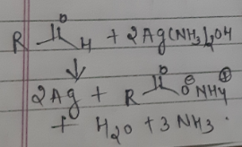

- Observations about the known compounds (hypothetical – considering you actually did the experiment in the lab):
- You analyzed acetophenone in the lab by following the Flow chart uploaded in Canvas. Record your observations as follows (your observations must be in accordance with what you expect of this compound).
Compound analyzed | Experiment | Observation | Inference  (what FG could be absent or present)
Acetophenone | Performed ignition/combustion test | Sooty flame noticed | Confirms the presence of an Aromatic compound
 | Performed Beilstein test | No blue color is seen | Absence of a halogen
 | Placed two drops of the compound in a test tube. Added about 1 mL of water. Stirred with a glass rod to solubilize the compound. Then warned it in a 60-70 °C water bath. | Insoluble | Aromatic carbonyl compounds don’t dissolve in water
 | Added ~ 1 mL of 5% NaOH solution to and stirred with a glass rod. | Insoluble | Aromatic carbonyl compounds don’t dissolve in water
 | Added a few drops of 5% NaHCO₃ to the compound and watched to see if tiny bubbles of carbon dioxide were produced | There is no effervescence | Aromatic carbonyl compounds don’t dissolve in basic solutions
 | Added a few drops of 5% HCl to the compound and watched to see if the compound dissolved. | Insoluble | Aromatic carbonyl compounds dissolve in acidic solutions
 | Dissolved 3 drops of the compound in 2 mL of reagent-grade ethanol and added 3 mL of the 2,4-dinitrophenylhydrazine (2,4-DNP) reagent | Orange to Reddish precipitate is seen | Ketone group is present
 | Added 3 drops of the compound to a test tube then added 5 drops of acetone and 5 drops of chromic acid solution. | Orange solution is seen | Absence of Alcohols such as aldehyde group
 | Prepared Tollens reagent (ammoniacal silver nitrate) first. Placed 2 mL of a 5% aqueous solution of silver nitrate (Tollens reagent A) in a small test tube. Add a drop of 10% NaOH (Tollens reagent B), producing brown silver oxide precipitate. Re-dissolve the precipitate by adding just enough dilute (2%) ammonia to dissolve the silver oxide precipitate. Add a few drops of this reagent to a small amount of the compound. Let the tube stand at room temp, or in a slightly warm water taken in beaker. | Orange precipitate is seen | Ketone group is present
Chemical equation/s of the reaction/s that gave definitive (confirmatory) information about this compound. You must use STRUCTURAL FORMULAS (hand-drawn, soft-ware drawn (NOT copied from the internet! Molcular formulas will not be acceptable and will get no credit.

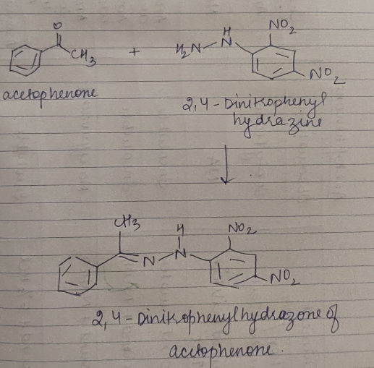

- Observations about the known compounds (hypothetical – considering you actually did the experiment in the lab):
- You analyzed methyl benzoate in the lab by following the Flow chart uploaded in Canvas. Record your observations as follows (your observations must be in accordance with what you expect of this compound).
Compound analyzed | Experiment | Observation | Inference  (what FG could be absent or present)
Methyl benzoate | Performed ignition/combustion test | Yellow flame observed but no soot | Aromatic ring or alkynes absent
 | Performed Beilstein test | No green/blue color observed in flame | Halogens are absent
 | Placed two drops of the compound in a test tube. Added about 1 mL of water. Stirred with a glass rod to solubilize the compound. Then warned it in a 60-70 °C water bath. | Immiscible, floats on cold as well as warm water | Low molecular weight alcohols, amines, carboxylic acids absent
 | Added ~ 1 mL of 5% NaOH solution to and stirred with a glass rod. | Immiscible | Compound is neither weak nor strongly acidic. So, phenol and carboxylic acid groups are absent.
 | Added a few drops of 5% NaHCO₃ to the compound and watched to see if tiny bubbles of carbon dioxide were produced | No bubbles observed | Carboxylic acid (-COOH) group is absent
 | Added a few drops of 5% HCl to the compound and watched to see if the compound dissolved. | Immiscible | Amines absent
 | Dissolved 3 drops of the compound in 2 mL of reagent-grade ethanol and added 3 mL of the 2,4-dinitrophenylhydrazine (2,4-DNP) reagent | Precipitates are not observed | Aldehydes/Ketones absent
 | Added 3 drops of the compound to a test tube then added 5 drops of acetone and 5 drops of chromic acid solution. | No color change | Alcohols and aldehydes absent
 | To a test tube containing place 3 drops of the compound, added 1 ml of 0.5 M hydroxylamine hydrochloride in 95% ethanol and 0.2 mL (3 drops) of 6.0 M NaOH. Placed the tube in a beaker containing boiling water for 4 minutes, cooled to room temperature. Added 1.0 mL of 1M HCl solution followed by 2 or 3 drops of 5% ferric chloride solution. | Reddish brown color of bromine disappears | Unsaturated compounds i.e. Alkenes or alkynes are present
Chemical equation/s of the reaction/s that gave definitive (confirmatory) information about this compound. You must use STRUCTURAL FORMULAS (hand-drawn, soft-ware drawn (NOT copied from the internet! Molcular formulas will not be acceptable and will get no credit.

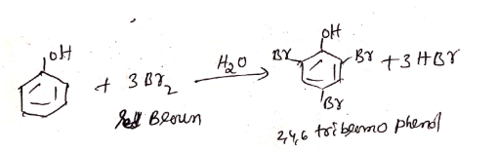

- Observations about the known compounds (hypothetical – considering you actually did the experiment in the lab):
- You analyzed nitrobenzene in the lab by following the Flow chart uploaded in Canvas. Record your observations as follows (your observations must be in accordance with what you expect of this compound).
Compound analyzed | Experiment | Observation | Inference  (what FG could be absent or present)
Nitrobenzene | Performed ignition/combustion test | Burned with fuming gas | Confirms he presence of an aromatic compound
 | Performed Beilstein test | No color flame is seen | The compound lacks Br, Cl, and I (halogens)
 | Placed two drops of the compound in a test tube. Added about 1 mL of water. Stirred with a glass rod to solubilize the compound. Then warned it in a 60-70 °C water bath. | No gases evolve | The compound is not amine
 | Added ~ 1 mL of 5% NaOH solution to and stirred with a glass rod. | No characteristic reaction | Compound not amide phenol and acid glucose
 | Added a few drops of 5% NaHCO₃ to the compound and watched to see if tiny bubbles of carbon dioxide were produced | No carbon dioxide bubbles | Confirms the absence of carboxylic acids
 | Added a few drops of 5% HCl to the compound and watched to see if the compound dissolved. | Not soluble | Absence of amine and basic compounds
 | Dissolved 3 drops of the compound in 2 mL of reagent-grade ethanol and added 3 mL of the 2,4-dinitrophenylhydrazine (2,4-DNP) reagent | No orange or yellow precipitate | Confirms the absence of alcohol
 | Added 3 drops of the compound to a test tube then added 5 drops of acetone and 5 drops of chromic acid solution. | Unrealistic reaction is seen | Confirms the absence of alcohol
 | Added 1.0 ml of 5% ferrous ammonium sulfate solution.to about 4 drops of the compound. Mixed and added 2 drop of 3 M sulfuric acid followed by 20 drops of 2 M KOH in methanol. Mixed thoroughly by shaking and allow to stand for 5 minutes. | No characteristic reaction is noticed | Absence of phenol naphthalol
Chemical equation/s of the reaction/s that gave definitive (confirmatory) information about this compound. You must use STRUCTURAL FORMULAS (hand-drawn, soft-ware drawn (NOT copied from the internet! Molcular formulas will not be acceptable and will get no credit.

